Federal Budget Submission
Requests to End Federal Inequalities for Persons with Disabilities
February 10th, 2023

Submitted by:
The Founding Members of
Childhood Disability Network Canada (est.2023)

In Canada,

DISABILITY POVERTY

Begins at Birth.

Introduction

We prepared this budget submission on behalf of caregivers and their children/youth with disabilities. Families whose children have complex needs (e.g. medical, intellectual, physical and behavioural) are in crisis across Canada due to inequalities in funding and services to support these children from birth onwards into adulthood. Many community agencies cannot provide adequate support when families seek assistance due to funding constraints with outdated and discriminatory policies.

We are confident that the recommendations outlined in this budget submission can significantly improve the lives of children with disabilities and their families. With your government’s action through critical resources and targeted policy changes, these families can benefit more equitably throughout their lifespan. Policy changes in other countries, such as Australia and New Zealand, have resulted in a positive outlook for their citizens with disabilities and their national economies. (National Disability Insurance Agency 2020)

Recommendations for Children & Youth with Disabilities

- Create a Lifetime Caregiver Income Benefit
- Triple the Child Disability Benefit
- Create Home & Vehicle Accessibility Grants

1. Necessity of a Lifetime Caregiver Income Benefit

Family caregiving is at the core of what sustains children, youth, and young adults with complex care needs. Direct care and care coordination is full-time and creates enormous employment barriers. (Finlay et al., 2023; youtube, 2022)

As a result, lifetime caregivers are often forced to make significant financial sacrifices, including loss of employment income, pensions, and workplace benefits. In addition, families are pushed towards poverty as disability-related expenses continue to rise and compound. (Lenahan 2021; Sarangi Leila 2021; Zafar 2023)
Caregivers are often forced to make life-altering decisions to help loved ones with disabilities remain in their homes. Unfortunately, these scarifies negatively impact families' financial, physical, and mental health status for years to come.

We ask you to create a robust Lifetime Caregiver Income Benefit* that recognizes the critical full-time work of family caregivers. Modelled on the Caregiver Recovery Benefit*
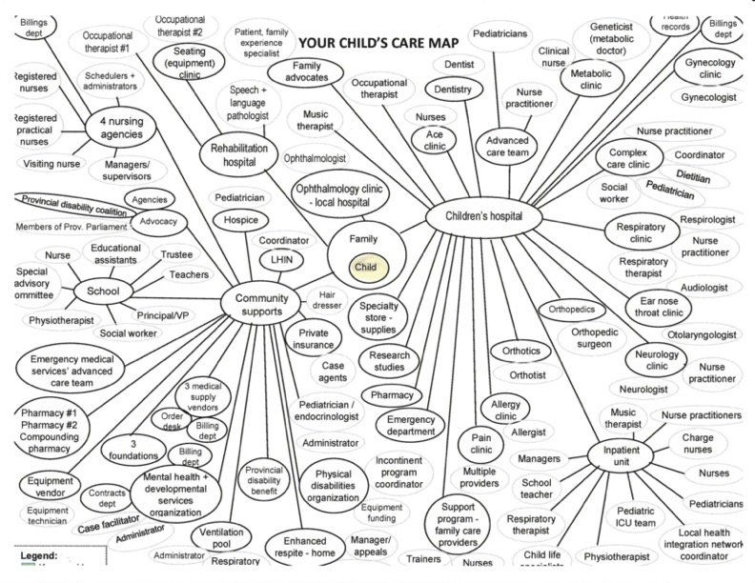

Image Description:
It shows a complex web of bubbles linked to a child-centred within a vast matrix of care providers with close to 100 contacts throughout the community, hospital, and home. This means that the caregiver, traditionally the mother of a child with complex needs, is using all her waking time, either coordinating care or providing direct care to her child 24 hours, seven days a week. There is no job which requires such skills, focus, and compassion with no compensation. This work is done with tremendous love, but it takes a financial, physical, and mental health toll on families and, most commonly, mothers.
(Bourke-Taylor et al. 2010)

The province of New Brunswick recognized the significant cost involved in raising children with complex needs (such as emotional, behavioural, medical, or related to mental health or trauma) is valued at $3500 a month with an additional $1769 in 2022. These funds are paid to adults (foster care parents) to stay home and focus on their care. (Cave 2022)
We ask you to create a lifetime caregiver income benefit across the lifespan.

2. Importance of Tripling the Child Disability Benefit
During these last three years of the pandemic, families with children & youth who have severe and prolonged disabilities have been disproportionately impacted. Unfortunately, along with years of inflating costs and eroding provincial programs, we have not yet seen the doubling of the Child Disability Benefit as promised to us for many years.

This policy change was mandated in Justin Trudeau's 2019 mandate letter: “Double the Child Disability Benefit and work with families and experts to ensure the Benefit is effective in providing help as most needed” (Trudeau 2019)

The current maximum benefit of $242/month is not supportive when we face such extraordinary costs for specialized care, therapy, equipment, and home & vehicle modifications which can be more than $40,000 annually. (McIntyre 2019)
Income testing the CDB is financially challenging for families. We recommend shifting the income threshold higher to reflect better the financial demands of having a child with complex care needs. The current threshold for reducing the CDB is $71,060 to $165,000. We recommend removing altogether or setting the reduction at $150K and scaling it to $250K

We understand that the current plans for the new Canada Disability Benefit are aimed at adults between the ages of 18-65. Therefore, we ask for consideration of automatically transitioning those people with disabilities whose caregivers receive the Child Disability Benefit into the Canada Disability Benefit program upon their 18th birthday.

We ask you to triple the Child Disability Benefit to $726.00 per month.

Need for Home & Vehicle Modifications Grants for Accessibility
Home modifications for accessibility are absolutely necessary for the safety and well-being of children with physical disabilities and their family caregivers. In addition, adapted vehicles are essential to meet the right to inclusion in the community. Unfortunately, these modifications are cost-prohibitive for the majority of families; many go without and are marginalized as a result.
The Federal Budget 2022 launched the refundable Multigenerational Home Renovation Tax Credit of $7500. However, this new credit excluded families who need to make accessibility modifications earlier in their children’s lives to prepare for supporting them at home into adulthood. (Ricci 2022)
Tax credits such as the Multigenerational Home Renovation Tax Credit must include families with children with disabilities.
According to Easter Seals Canada, “A specially designed walker can cost up to $2,500. A customized power wheelchair can cost more than $25,000. A porch lift can cost upwards of $5,000.” To meet these increasingly costly but needed supports, The Home Accessibility Tax Credit needs to be significantly increased beyond $3000. Also, consideration should be made to having the credit refundable for those whose income is under $150K.
(Crawford 2019; Malacrida 2010)
Create funding opportunities for families who require accessible rental housing, including rent subsidies and equipment grants suitable for adapting rental property.

We ask you to create home & vehicle modifications accessibility grants across the lifespan.

In Conclusion
As a committed signatory of the United Nations Convention of Rights for persons with disabilities & United Nations Convention on the Rights of the Child, we urge this government to make essential policy changes and demonstrate your commitment through action.

Our recommendations would make significant strides in reducing childhood disability poverty. Children have the right to thrive at home with their families in a more equitable way with their peers.

We ask you to use a rights-based approach to policy for a better future for all people with disabilities living in Canada, including children & youth. (Lai (Ph.D.) and Shikako-Thomas, Ph.D. 2018)

Let’s support our children with disabilities and their families throughout their lifetime. We ask your government to implement a lifetime caregiver income benefit, triple the Child Disability Benefit and create accessibility grants for home and vehicle modifications. Through these actions, we will work together to create a barrier-free Canada.

Contacts
Sherry Caldwell
childhooddisabilitynetwork@gmail.com
Tel: 416-903-5067

Reference List:
Accelerating Accessibility Coalition. “Accelerating Accessibility Coalition - Americas.” ULI Toronto. https://toronto.uli.org/programs/the-accelerating-accessibility-coalition/#:~:text=The%20Accelerating%20Accessibility%20Coalition%20(AAC.
2019. “Canadian Human Rights Act.” Justice.gc.ca. https://laws-lois.justice.gc.ca/eng/acts/h-6/page-1.html.
Australian Building Codes Board. 2022. “New livable housing design requirements | ABCB.” www.abcb.gov.au. https://www.abcb.gov.au/news/2022/new-livable-housing-design-requirements.
Bourke-Taylor, H., L. Howie, and M. Law. 2010. “Impact of caring for a school-aged child with a disability: Understanding mothers’ perspectives.” Australian Occupational Therapy Journal 57(2):127–136.
Caldwell, S., N. Payette, M. White, J. Witt, T. Martin, and I. Wellington. 2021. “Let's talk about Solutions for the Home Care Nursing Crisis.” @ODCoalition. Ontario Disability Coalition. https://odcoalition.com/2021/11/15/lets-talk-about-solutions-for-the-home-care-nursing-crisis/.
Canada, M. of D. 2023. “https://www.marchofdimes.ca/en-ca/aboutus/govtrelations/ourwork/Pages/federal-pre-budget-submission-2022.aspx.” Marchofdimes.ca. https://www.marchofdimes.ca/enca/aboutus/govtrelations/provincial/Documents/M.
CareMakers Foundation, P. C. 2022. “Petro-Canada CareMakers Foundation – A Caregiver’s Evening.” www.youtube.com. https://www.youtube.com/watch?v=HPl8efRsBDc.
Cave, R. 2022. “New Brunswick launches new model of care for youth with complex needs.” CBC. https://www.cbc.ca/news/canada/new-brunswick/care-homes-youth-bruce-fitch-1.6458063.
Cheung, K. 2022. “OUR MESSAGE.” https://www.accessiblehousingnetwork.org/. Accessible Housing Network Steering Committee. https://www.accessiblehousingnetwork.org/our-message-2.
Crawford, B. 2019. “Breaking barriers: accessibility at home a costly process.” ottawacitizen. https://ottawacitizen.com/news/local-news/ottawa-firm-specializes-in-accessibilty-renovations.
Finlay, B., K. Wittevrongel, D. Materula, M. L. Hébert, K. O’Grady, L. M. Lach, D. Nicholas, and J. D. Zwicker. 2023. “Pan-Canadian caregiver experiences in accessing government disability programs: A mixed methods study.” Research in Developmental Disabilities 134(volume 134):104420.
https://canadiancaregiving.org/. 2022. Giving Care An approach to a better caregiving landscape in Canada.
Lai (PhD), J. L., and K. Shikako-Thomas, PhD. 2018. RIGHTS-BASED APPROACHES FOR CHILDREN WITH DISABILITIES IN CANADA.
Lenahan, B. 2021. “Dear Canadians: Please care about families like mine.” QUOI Media Group. https://quoimedia.com/dear-canadians-please-care-about-families-like-mine/.
Malacrida, C. 2010. “Income support policy in Canada and the UK: different, but much the same.” Disability & Society 25(6):673–686.
McIntyre, G. 2019. “Disability in Canada: Facts & Figures.” Easter Seals Canada. https://easterseals.ca/en/disability-in-canada-facts-figures/.
National Disability Insurance Agency. 2020. “NDIS CEO address to the Council for Economic Development of Australia | NDIS.” www.ndis.gov.au. https://www.ndis.gov.au/news/4413-ceo-address-council-economic-development-australia.
Ricci, T. 2022. “Temagami, Ont., family says they need more support to care for a son with cerebral palsy.” CBC News. https://www.cbc.ca/news/canada/sudbury/cerebral-palsy-provincial-funding-1.6629085.
Sarangi Leila, C. 2000. 2021. “No One Left Behind: Strategies for an Inclusive Recovery.” Campaign 2000. https://campaign2000.ca/no-one-left-behind-strategies-for-an-inclusive-recovery/.
Tompa, E., A. Mofidi, A. Jetha, P. Lahey, and A. Buettgen. 2020. “Equality, Diversity and Inclusion: Vol. 41 Iss. 3 | Emerald Insight.” www.emerald.com. https://www.emerald.com/insight/publication/issn/2040-7149/vol/41/iss/3.
Trudeau, P. M. J. 2019. “ARCHIVED - Minister of Employment, Workforce Development and Disability Inclusion Mandate Letter.” Prime Minister of Canada. https://pm.gc.ca/en/mandate-letters/2019/12/13/archived-minister-employment-workforce-development-and-disability.
United Nations. 1948. “Universal Declaration of Human Rights.” United Nations. United Nations. https://www.un.org/en/about-us/universal-declaration-of-human-rights.
United Nations Human Rights Office of the High Commissioner. 2022. “OHCHR | The human right to adequate housing.” OHCHR. https://www.ohchr.org/en/special-procedures/sr-housing/human-right-adequate-housing.
Youtube, P. C. A. 2022. “Petro-Canada CareMakers Foundation – 24 Hours of Care.” www.youtube.com. Caremakers Foundation. https://www.youtube.com/watch?v=ixGoGVnO07Q.
Zafar, K. 2023. “Being a parent of a disabled child means finances can be tight. Months of inflation and government shortfalls make it worse.” thestar.com. https://www.thestar.com/opinion/2023/01/19/being-a-parent-of-a-disabled-child-means-finances-can-be-tight-months-of-inflation-and-government-shortfalls-make-it-worse.html.

